JSON file

The JSON (JavaScript Object Notation) file is the file that feeds data into the JavaScript so that elements can be built. It allows the project to be dynamic, meaning “changing”, as none of the data is hard-coded into the original source code. Quiz elements like questions, answers, answer weightings, pie chart data, and even quiz slides, are all created with objects from the JSON file.

The JSON file is meant to be easy for humans to read and write, which is why it was used in this project. The goal was to make updating and maintaining the quiz simple and intuitive enough so that someone without coding experience could do it.

# Changing the JSON

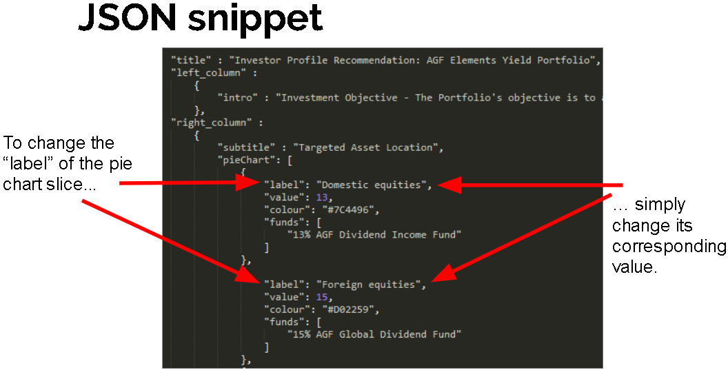

# About data.json